PRACTICAL 6 REPORT
Module Name: Grade Calculation Module
Test Case ID: TC001–TC005
Program: Python Grade Calculation Program
Website Url: https://helpful-brigadeiros-3509bc.netlify.app/
Scenario ID: TC001
Scenario: Verify grade calculation for different marks
Test Steps:
- 1. Enter marks for Grade A.
2. Enter marks for Grade B.
3. Enter marks for Grade C.
4. Enter marks for Grade F.
5. Enter invalid marks.

Test Input: Marks: 95, 85, 75, 30, 110
Expected Result: Grade A, Grade B, Grade C, Grade F, and Invalid marks respectively.
Actual Result: Grade A, Grade B, Grade C, Grade F, and Invalid marks displayed respectively.
Status: Pass
Screenshot:
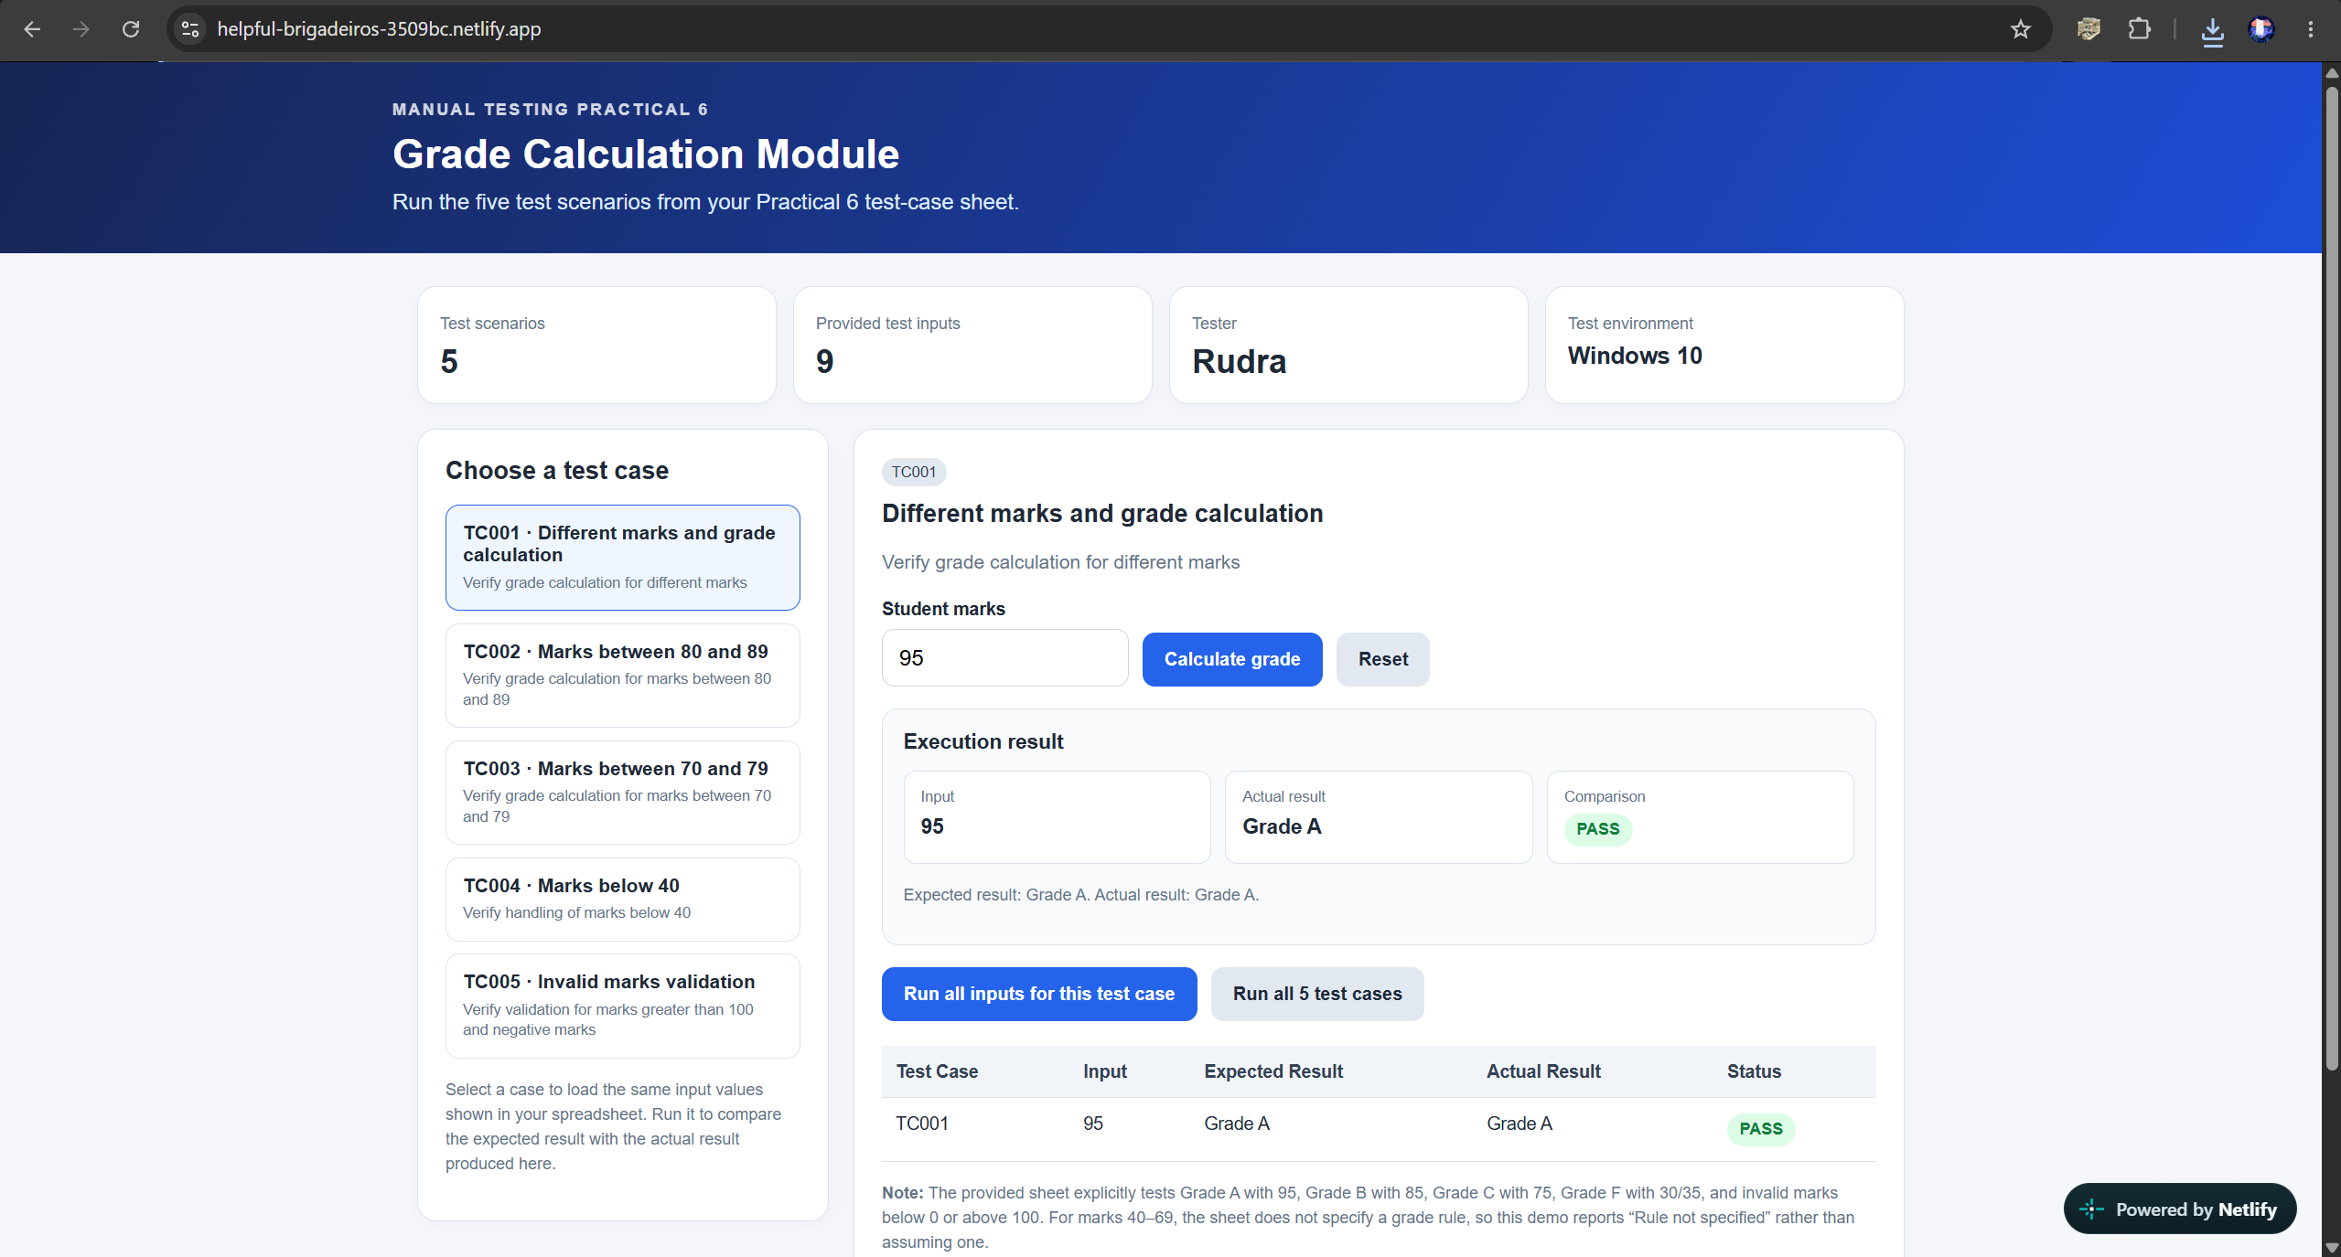
Scenario ID: TC002
Scenario: Verify grade calculation for marks between 80 and 89
Test Steps:
- 1. Run the Python grade calculation program.
- 2. Enter marks: 85.
- 3. Check the displayed grade.
- 4. Compare the result with the expected grade.
Test Input: Marks: 85
Expected Result: Grade B should be displayed.
Actual Result: Grade B displayed.
Status: Pass
Screenshot: 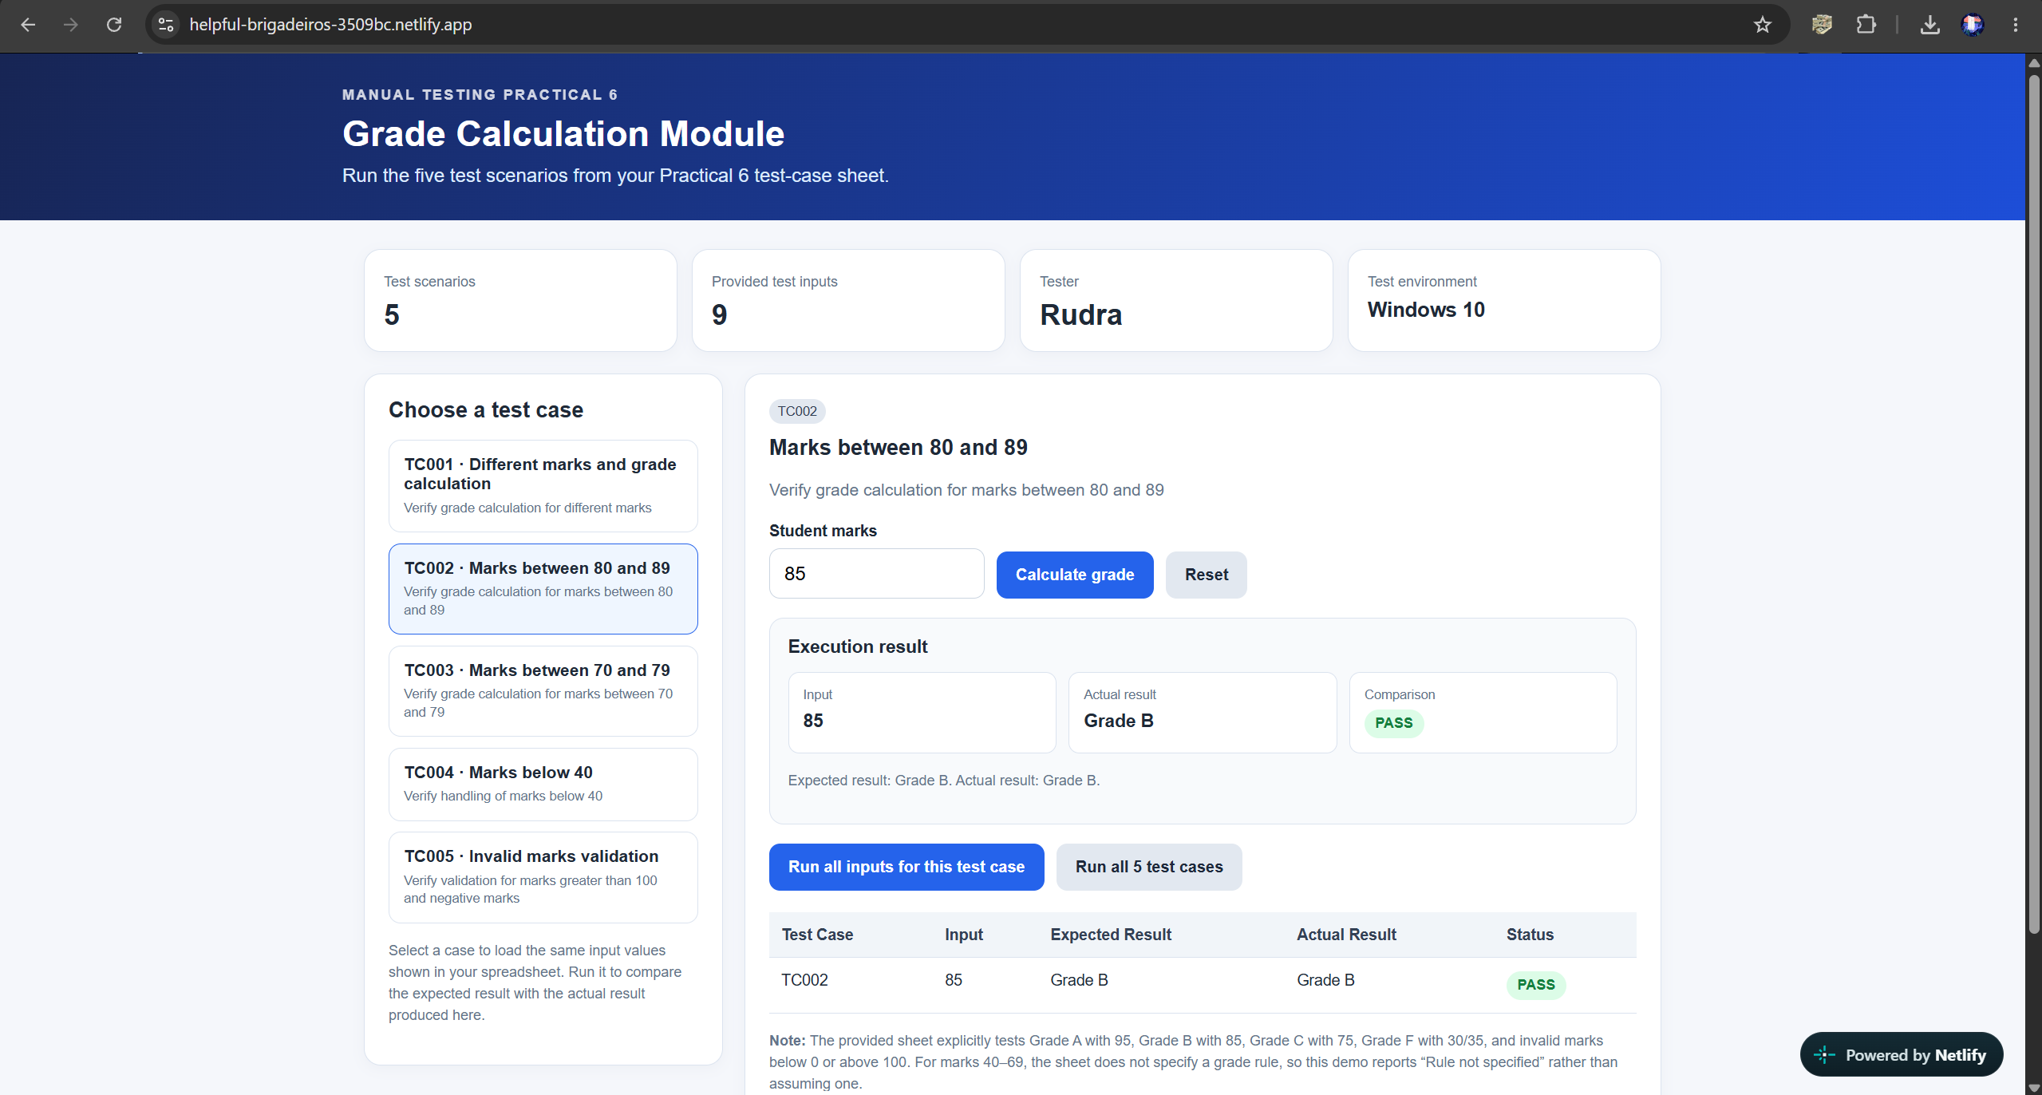

Scenario ID: TC003
Scenario: Verify grade calculation for marks between 70 and 79
Test Steps:
- 1. Run the Python grade calculation program.
- 2. Enter marks: 75.
- 3. Check the displayed grade.
- 4. Compare the result with the expected grade.
Test Input: Marks: 75
Expected Result: Grade C should be displayed.
Actual Result: Grade C displayed.
Status: Pass
Screenshot:
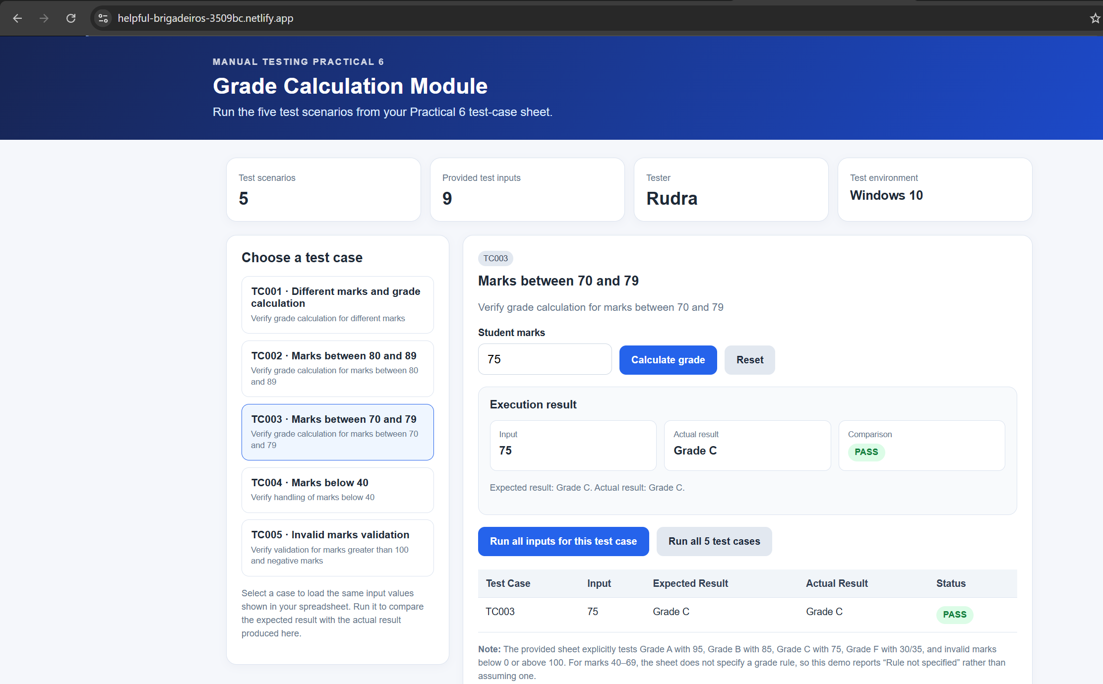

Scenario ID: TC004
Scenario: Verify handling of marks below 40
Test Steps:
- 1. Run the Python grade calculation program.
- 2. Enter marks: 35.
- 3. Check the displayed grade.
- 4. Compare the result with the expected grade.
Test Input: Marks: 35
Expected Result: Grade F should be displayed.
Actual Result: Grade F displayed.
Status: Pass
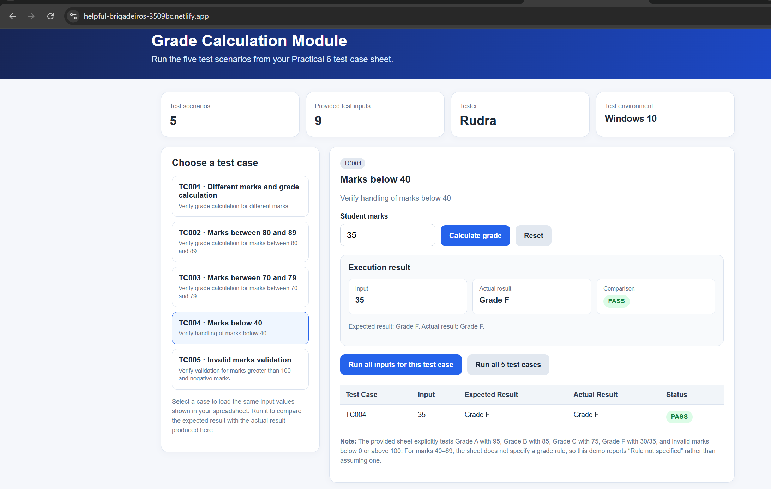
Scenario ID: TC005
Scenario: Verify validation for marks greater than 100 and negative marks
Test Steps:
- 1. Run the Python grade calculation program.
- 2. Enter marks: 105 and check the result.
- 3. Enter marks: -5 and check the result.
- 4. Verify both inputs are rejected as invalid marks.
Test Input: Marks: 105, -5
Expected Result: Invalid marks message should be displayed for both inputs.
Actual Result: Invalid marks displayed for both inputs.
Status: Pass

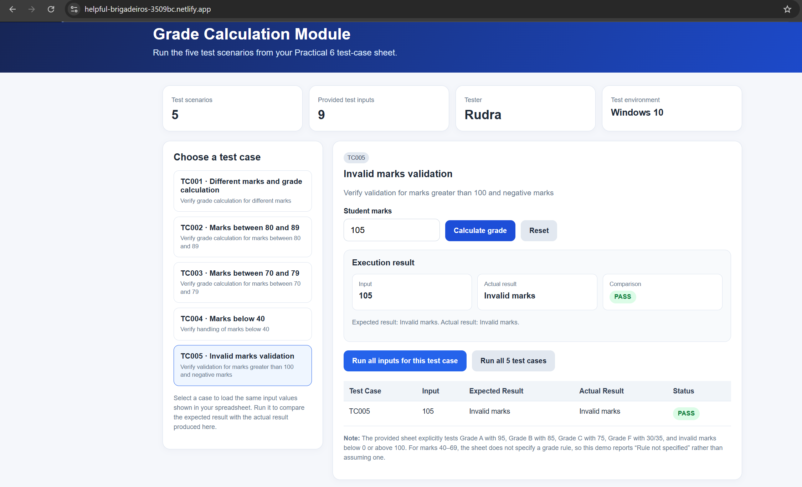

Summary of Test Results
Total Test Scenarios | 5
Passed | 5
Failed | 0
Pass Percentage | 100%

Conclusion and Recommendations
This report documents five test cases for the Grade Calculation Module. All five test cases are marked Pass in the supplied spreadsheet. Add the relevant execution screenshots in the spaces provided before submitting the report.
Recommendation: Continue testing boundary values around each grade range and confirm that all marks below 0 or above 100 are rejected as invalid.

